**GALGOTIAS UNIVERSITY**

**DEPARTMENT OF COMPUTER SCIENCE AND ENGINEERING**



|  |  |  |  |
| --- | --- | --- | --- |
| **SUBJECT** | **Semi-conductor Physics** | **PROGRAMME** | **B. Tech.** |
| **SUBJECT CODE** | **BBS01T1002** | **BRANCH/SEMESTER** | **I** |
| **SECTION** | **23** | **FACULTY NAME** | **Susmita Majumdar** |
| **NAME STUDENT 1** | **Navin yadav** | **ENROLLMENT NO STUDNET 1** | **21SCSE1180291** |
| **NAME STUDENT 2** | **Neeraj singh** | **ENROLLMENT NO STUDNET 2** | **21SCSE1011675** |
| **NAME STUDENT 3** | **Nikhil kanojia** | **ENROLLMENT NO STUDNET 3** | **21SCSE11802285** |
| **NAME STUDENT 4** | **Nitin kumar** | **ENROLLMENT NO STUDNET 3** | **21SCSE1011671** |

|  |
| --- |
| **Topic** |

*Biasing of PN –Junction Diode and I-V characteristics*

*P-N Junction-*

*A p-n junction is an interface or a boundary between two semiconductor material types, namely the p-type and the n-type, inside a semiconductor.*

*The p-side or the positive side of the semiconductor has an excess of holesand the n-side or the negative side has an excess of electrons. In a semiconductor, the p-n junction is created by the method of doping. The process of doping is explained in further detail in the next section.*

*Formation of P-N Junction-*

*Let us consider a thin p-type silicon semiconductor sheet. If we add a small amount of pentavalent impurity to this, a part of the p-type Si will getconverted to n-type silicon. This sheet will now contain both p-type regionand n-type region and a junction between these two regions. The processesthat follow after the formation of a p-n junction are of two types – diffusionand drift. As we know, there is a difference in the concentration of holes andelectrons at the two sides of a junction, the holes from the p-side diffuse tothe n-side and the electrons from the n-side diffuse to the p-side. These give* rise to a diffusion current across the junction.

*Forward Bias-*

*When the p-type is connected to the positive terminal of the battery and the n-type to the negative terminal then the p-n junction is said to be forward-biased. When the p-n junction is forward biased, the built-in electric field at the p-n junction and the applied electric field are in opposite directions. When both the electric fields add up the resultant electric field has a magnitude lesser than the built-in electric field. This results in a less resistive and thinner depletion region. The depletion region’s resistance becomes negligible when the applied voltage is large. In silicon, at the voltage of 0.6 V, the resistance of the depletion region becomes completely negligible and the current flows across it unimpeded.*

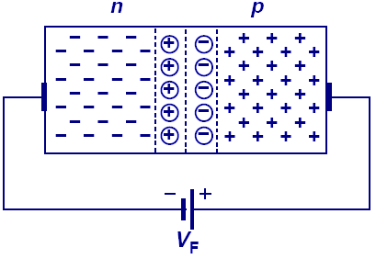

*Reverse Bias-*

*When the p-type is connected to the negative terminal of the battery and the n-type is connected to the positive side then the p-n junction is said to be reverse biased. In this case, the built-in electric field and the applied electric field are in the same direction. When the two fields are added, the resultant electric field is in the same direction as the built-in electric field creating a more resistive, thicker depletion region. The depletion region becomes more resistive and thicker if the applied voltage becomes larger.*

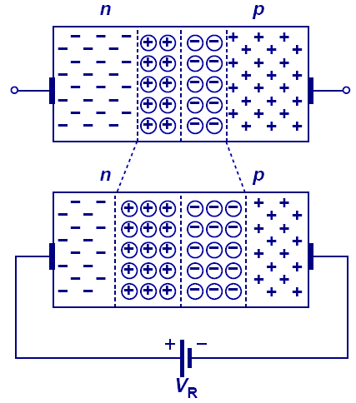

1. *V Characteristics of PN Junction Diode-*

*I-V characteristics of PN junction diode is a curve between the voltage and current through the circuit. Voltage is taken along the x-axis while the current is taken along the y-axis. The above graph is the I-V characteristics curve of the PN junction diode. With the help of the curve we can understand that there are three regions in which the diode works, and they are:*

* *Zero bias*
* *Forward bias*
* *Reverse bias*

*When the PN junction diode is under zero bias condition, there is no*

*external voltage applied and this means that the potential barrier at the junction does not allow the flow of current.*

*When the PN junction diode is under forward bias condition, the p-type is connected to the positive terminal while the n-type is connected to the negative terminal of the external voltage. In this manner, there is a reduction in the potential barrier. For silicone diodes, when the voltage is 0.7V and for germanium diodes, when the voltage is 0.3 V, the potential barriers decreases and there is a flow of current. When the diode is in forward bias, the current increases slowly and the curve obtained is nonlinear as the voltage applied to the diode is overcoming the potential barrier. Once the potential barrier is overcome by the diode, the diode behaves normal and the curve rises sharply as the external voltage increases and the curve so obtained is linear. When the PN junction diode is under reverse bias condition, the ptype is connected to the negative terminal while the n-type is connected to the positive terminal of the external voltage. This results in an increase in the potential barrier.*

*Reverse saturation current flows in the beginning as minority carriers are present in the junction. When the applied voltage is increased, the minority charges will have increased kinetic energy which affects the majority charges. This is the stage when the diode breaks down. This may also destroy the diode.*

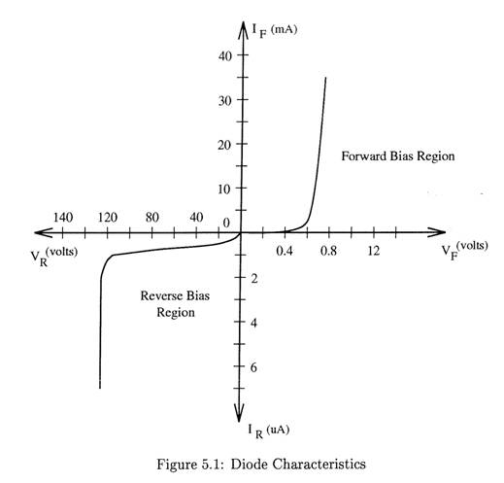

*Zener diode-*

*A normal p-n junction diode does not operate in breakdown region because the excess current permanently damages the diode. Normal p-n junction diodes are not designed to operate in reverse breakdown region.*

*Therefore, a normal p-n junction diode does not operate in reverse*

*breakdown region.*

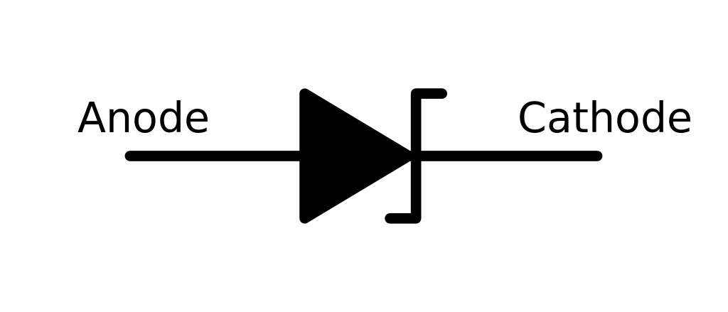

*There are two types of reverse breakdown regions in a zener diode:*

* *Zener breakdown.*
* *Avalanche breakdown*

*Avalanche breakdown-*

*The avalanche breakdown occurs in both normal diodes and zener diodes at high reverse voltage. When high reverse voltage is applied to the p-n junction diode, the free electrons (minority carriers) gains large amount of energy and accelerated to greater velocities. The free electrons moving at high speed will collides with the atoms and knock off more electrons. These electrons are again accelerated and collide with other atoms. Because of this continuous collision with the atoms, a large number of free electrons are generated. As a result, electric current in the diode increases rapidly. This sudden increase in electric current may permanently destroys the normal diode. However, avalanche diodes may not be destroyed because they are*

*carefully designed to operate in avalanche breakdown region. Avalanche breakdown occurs in zener diodes with zener voltage (Vz) greater than 6V.*

*Zener breakdown-*

The zener breakdown occurs in heavily doped p-n junction diodes

because of their narrow depletion region. When reverse biased voltage applied to the diode is increased, the narrow depletion region generates strong electric field. When reverse biased voltage applied to the diode reaches close to zener voltage, the electric field in the depletion region is strong enough to pull electrons from their valence band. The valence electrons which gains sufficient energy from the strong electric field of depletion region will breaks bonding with the parent atom. The valance electrons which break bonding with parent atom will become free electrons.

This free electrons carry electric current from one place to another place. Atzener breakdown region, a small increase in voltage will rapidly increases the electric current.

*Applications of PN Junction Diode*

* *P-N junction diode can be used as a photodiode as the diode is*

*sensitive to the light when the configuration of the diode is reverse-biased.*

* *It can be used as a solar cell.*
* *When the diode is forward-biased, it can be used in LED lighting*

*applications.*

* *It is used as rectifiers in many electric circuits and as a voltage controlled oscillator in varactors.*